Titanic Prediction – Code Explanation

1. Project Overview
This project predicts whether a passenger was transported or not using machine learning. The dataset comes from the Kaggle “Spaceship Titanic” competition. The code loads the training and test datasets, preprocesses the data, trains a machine learning model (Random Forest), evaluates the model, and finally creates a submission file for Kaggle.

Competition Screenshot
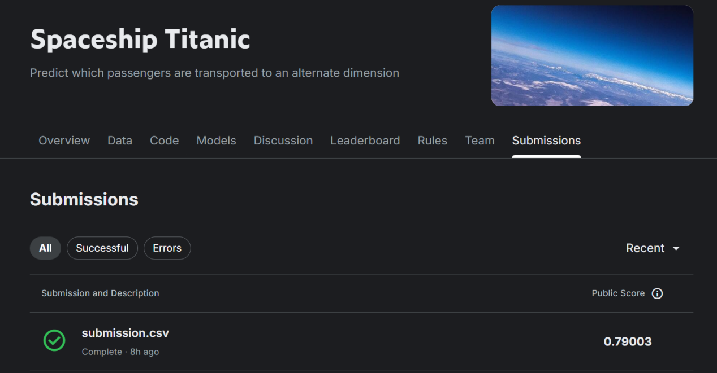
The above screenshot shows the Kaggle competition submission page with a successful submission and a public score.

2. Importing Libraries
The first step is importing all required Python libraries:
- pandas for data handling and numerical operations.
- sklearn modules for preprocessing, splitting the dataset, and evaluating the model.
- RandomForestClassifier for building the machine learning classification model.

3. Loading the Dataset
The training dataset (train.csv) and testing dataset (test.csv) are loaded using pandas.
- The training dataset contains passenger features and the target variable Transported.
- The test dataset contains passenger features but does not include the Transported column.
The model learns patterns from the training dataset and predicts results for the test dataset.

4. Feature Selection
The code selects important features from the dataset.
Two types of features are used:

Numerical Features
Examples include:
- Age
- RoomService
- FoodCourt
- ShoppingMall
- Spa
- VRDeck

Categorical Features
Examples include:
- HomePlanet
- Destination
- VIP
- CryoSleep
These features describe passenger behavior and status and help the model learn patterns for prediction.

5. Data Preprocessing
Before training the model, missing values and categorical data must be handled.
- Numerical features use SimpleImputer with the median strategy to replace missing values.
- Categorical features use the most frequent value to fill missing data.
- OneHotEncoder converts categorical variables into numerical vectors so the machine learning model can understand them.
A ColumnTransformer combines both numerical and categorical preprocessing steps.

6. Model Creation (Random Forest)
The code uses the RandomForestClassifier model.
Random Forest is an ensemble learning algorithm that builds multiple decision trees and combines their predictions to produce the final result.
Important characteristics include:
- High accuracy
- Handles complex data relationships
- Reduces overfitting compared to a single decision tree
Each decision tree makes a prediction and the final result is determined by majority voting.

7. Training Pipeline
A machine learning pipeline is created.
The pipeline ensures that data preprocessing and model training happen together in one workflow. This makes the code cleaner and prevents errors during prediction.

8. Model Training and Validation
The dataset is split into training and validation sets using train_test_split.
- The model is trained using the training data.
- Predictions are made on the validation data.
Model performance is evaluated using accuracy_score, which measures the percentage of correct predictions.

9. Accuracy Calculation
Accuracy is calculated by comparing the predicted values with the actual values in the validation dataset.

10. Training on Full Dataset
After validating the model, it is trained again using the full training dataset so the model can learn from all available data before making final predictions.

11. Making Predictions
The trained model predicts whether passengers in the test dataset were Transported (True or False).
These predictions represent the final output of the model.

12. Creating Submission File
Finally, the predicted results are saved into a submission.csv file with two columns:
- PassengerId
- Transported
This file can then be uploaded to Kaggle to receive a score on the leaderboard.

